**Evidence Gathering Document for SQA Level 8 Professional Developer Award.**

This document is designed for you to present your screenshots and diagrams relevant to the PDA and to also give a short description of what you are showing to clarify understanding for the assessor.

|  |  |  |  |
| --- | --- | --- | --- |
| **Unit** | **Ref.** | **Evidence** | **Done** |
| I & T | I.T 5 | Demonstrate the use of an array in a program. Take screenshots of:  *An array in a program  *A function that uses the array  *The result of the function running |  |

Each point that required details the Assessment Criteria (What you have to show) along with a brief description of the kind of things you should be showing.

Please fill in each point with screenshot or diagram and description.

**Week 2**

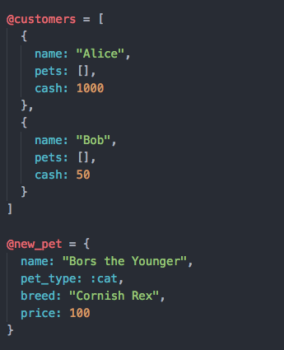

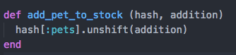

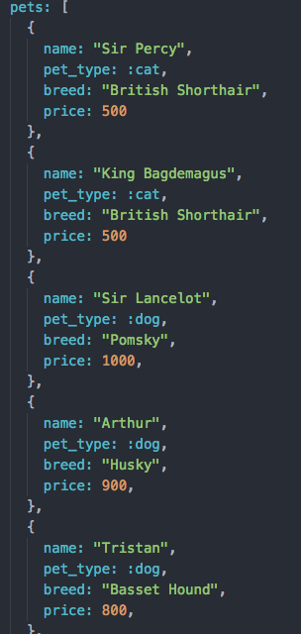

| Unit | Ref | Evidence |  |
| --- | --- | --- | --- |
| I&T | I.T.6 | Demonstrate the use of a hash in a program. Take screenshots of:  *A hash in a program  *A function that uses the hash  *The result of the function running | |

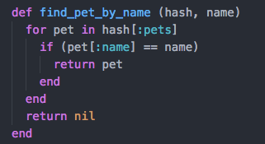



**Week 3**

| Unit | Ref | Evidence |  |
| --- | --- | --- | --- |
| I&T | I.T.3 | Demonstrate searching data in a program. Take screenshots of:  *Function that searches data  *The result of the function running | |

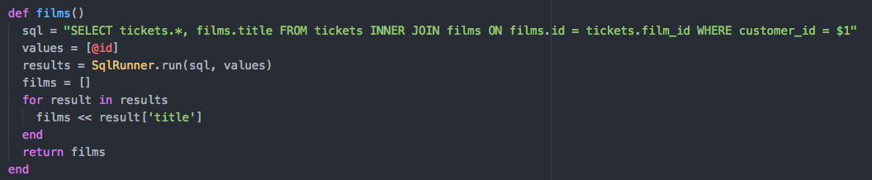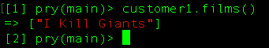

| Unit | Ref | Evidence |  |
| --- | --- | --- | --- |
| I&T | I.T.4 | Demonstrate sorting data in a program. Take screenshots of:  *Function that sorts data  *The result of the function running | |

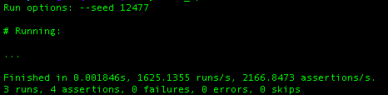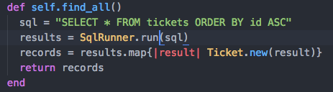

**Week 5**

| Unit | Ref | Evidence |  |
| --- | --- | --- | --- |
| A&D | A.D.1 | A Use Case Diagram | |

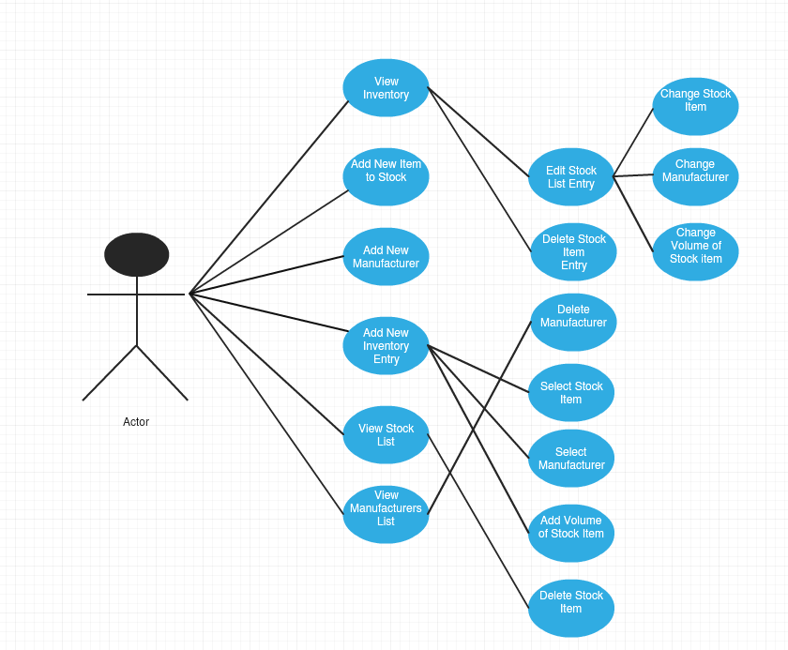

| Unit | Ref | Evidence |  |
| --- | --- | --- | --- |
| A&D | A.D.2 | A Class Diagram | |

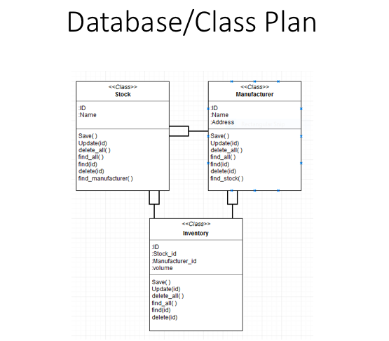

| Unit | Ref | Evidence |  |
| --- | --- | --- | --- |
| A&D | A.D.3 | An Object Diagram | |

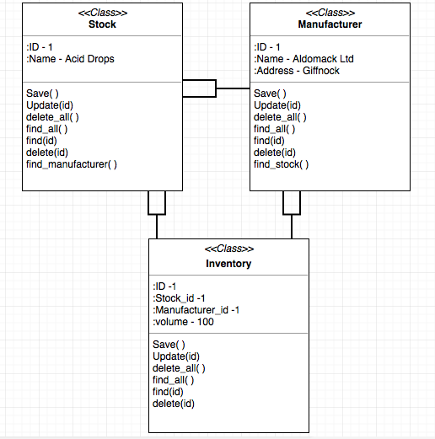

| Unit | Ref | Evidence |  |
| --- | --- | --- | --- |
| A&D | A.D.4 | An Activity Diagram | |

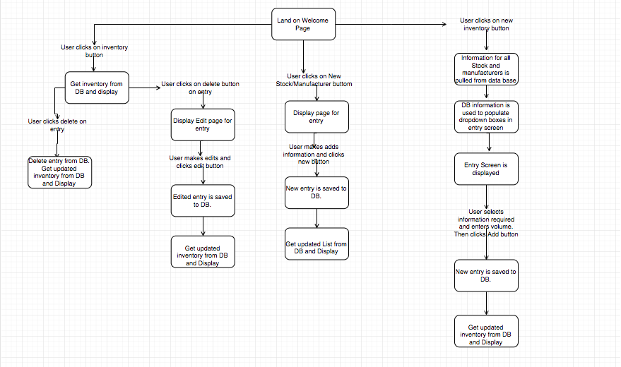

| Unit | Ref | Evidence |  |
| --- | --- | --- | --- |
| A&D | A.D.6 | Produce an Implementations Constraints plan detailing the following factors:  *Hardware and software platforms  *Performance requirements  *Persistent storage and transactions  *Usability  *Budgets  *Time | |

|  |  |  |
| --- | --- | --- |
| **Implementation Constraints Plan** | | |
| **Topic** | **Possible effect of the constraint on Product** | **Solution** |
|
| Hardware and Software Platforms | Using an out of date browser could compromise the users ability to access content | Update browsers to latest version |
|
| Performance Requirements | Slow internet connection could cause timeout errors etc making the application inaccessible | Make the bandwidth required to load the pages to a minimum. Ie no large images etc |
|
| Persistant Strorage | Limited Storage space could mean that should the users business expand there might not be enough space to store data on all stock | Expand storage space or use a third party provider to allow for scaling in future. |
|
| Usability | Application currently has issues displaying on table or mobile device | Make the application available on smaller screen sizes by Improving CSS |
|
| Budgets | Budget might be too small for the project the client currently wants us to undertake | Ask the client to increase the budget or provide cheaper options for basic functionality |
|
| Time Limitations | Short deadline leave little room for unforeseeable issues | Plan extensively and seek help if issues occur as early as possible |
|

| Unit | Ref | Evidence |  |
| --- | --- | --- | --- |
| P | P.5 | User Site Map | |

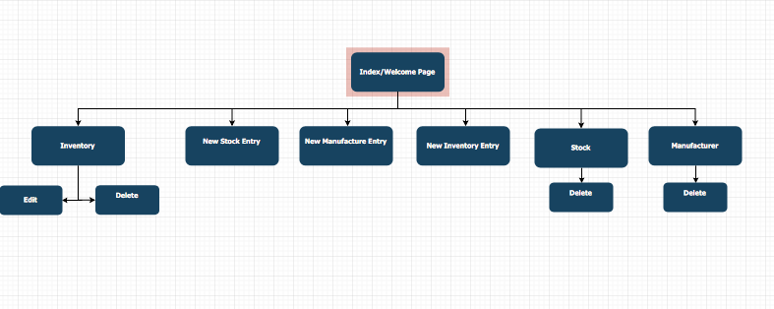

| Unit | Ref | Evidence |  |
| --- | --- | --- | --- |
| P | P.6 | 2 Wireframe Diagrams | |

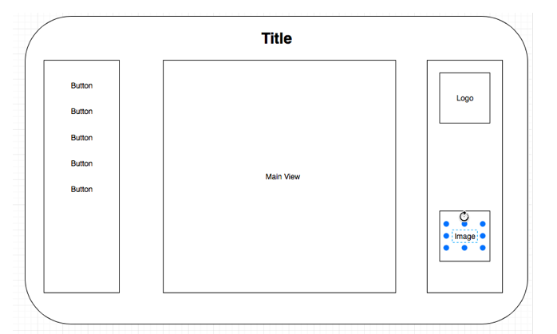

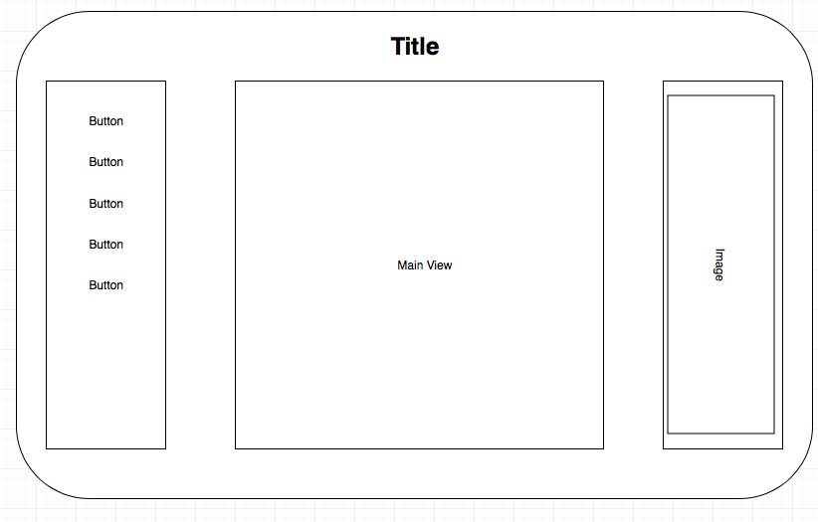

| Unit | Ref | Evidence |  |
| --- | --- | --- | --- |
| P | P.10 | Example of Pseudocode used for a method | |

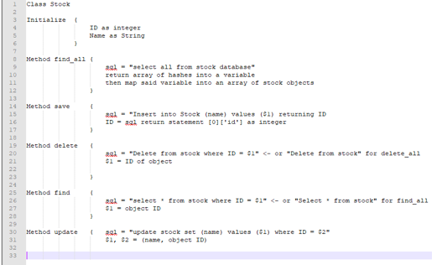

| Unit | Ref | Evidence |  |
| --- | --- | --- | --- |
| P | P.13 | Show user input being processed according to design requirements. Take a screenshot of:  * The user inputting something into your program  * The user input being saved or used in some way | |

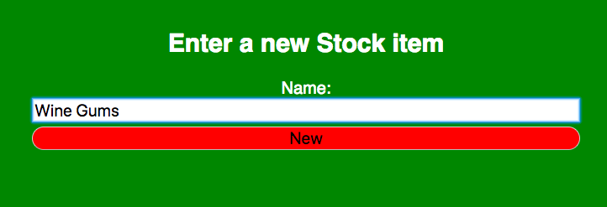

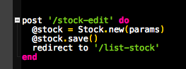

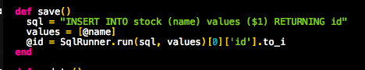

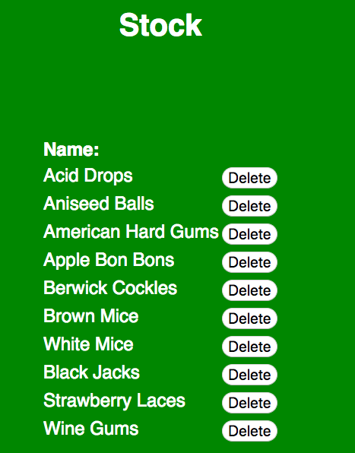

| Unit | Ref | Evidence |  |
| --- | --- | --- | --- |
| P | P.14 | Show an interaction with data persistence. Take a screenshot of:  * Data being inputted into your program  * Confirmation of the data being saved | |

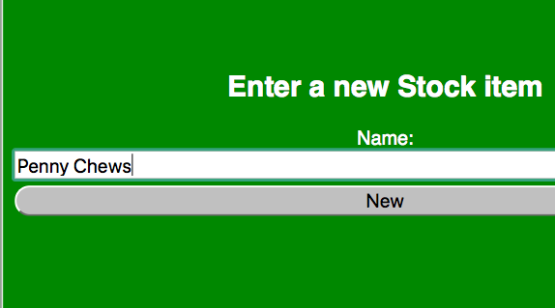

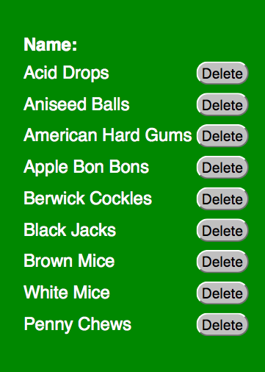

| Unit | Ref | Evidence |  |
| --- | --- | --- | --- |
| P | P.15 | Show the correct output of results and feedback to user. Take a screenshot of:  * The user requesting information or an action to be performed  * The user request being processed correctly and demonstrated in the program | |

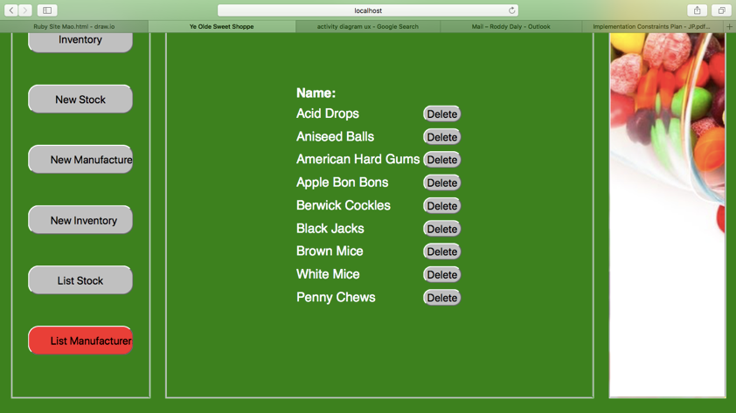

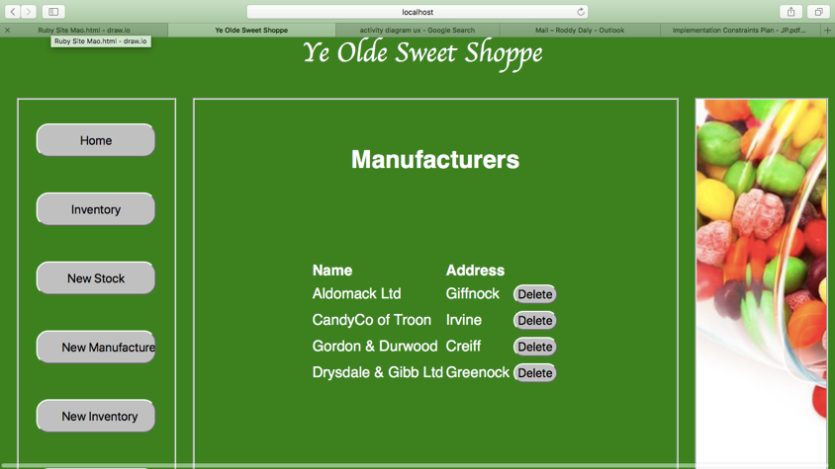

| Unit | Ref | Evidence |  |
| --- | --- | --- | --- |
| P | P.18 | Demonstrate testing in your program. Take screenshots of:  * Example of test code  * The test code failing to pass  * Example of the test code once errors have been corrected  * The test code passing | |

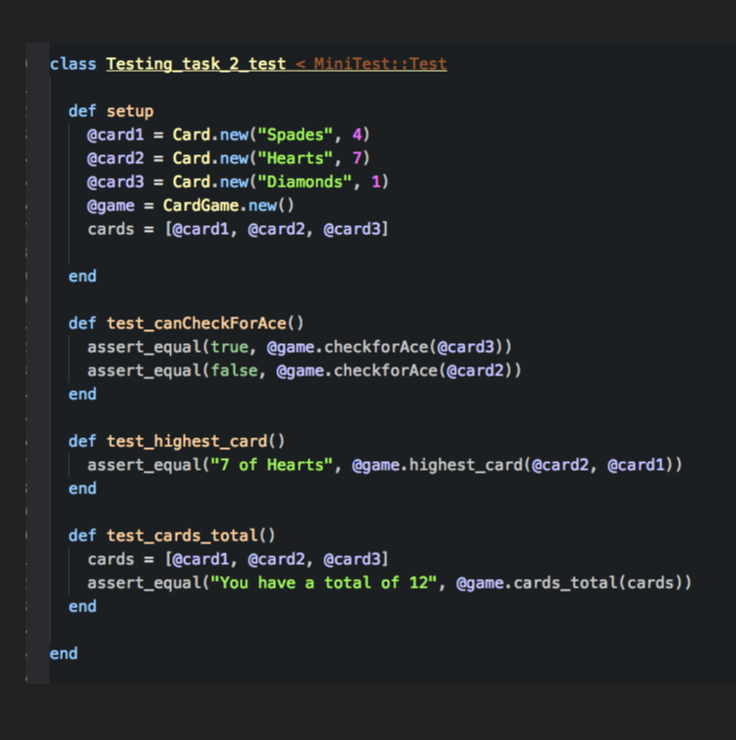

**Tests**

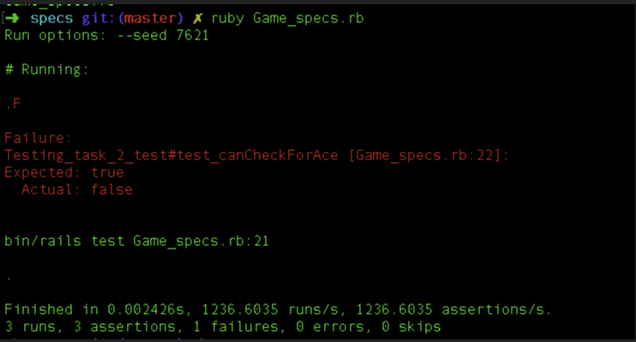

**Failed: canCheckForAce**

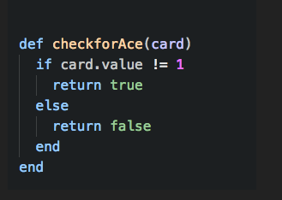

**Failed Method**

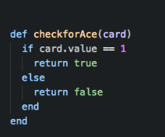

**Method Now Corrected**

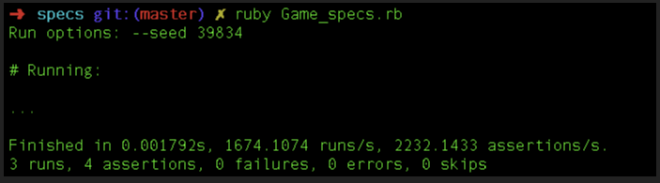

**Tests Now Pass**

**Week 7**

| Unit | Ref | Evidence |  |
| --- | --- | --- | --- |
| I&T | I.T.7 | The use of Polymorphism in a program and what it is doing. | |

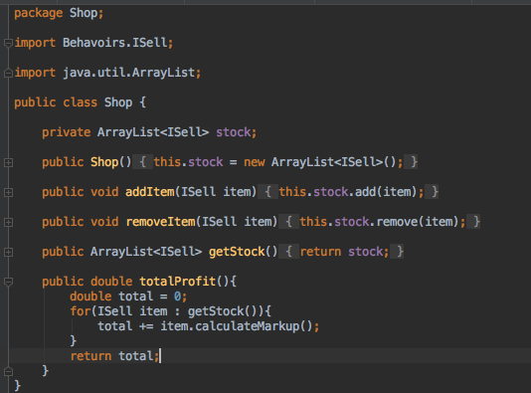



Here all objects implement the ISell interface and as such can be added into and ArrayList of ISell Objects

| Unit | Ref | Evidence |  |
| --- | --- | --- | --- |
| A&D | A.D.5 | An Inheritance Diagram | |

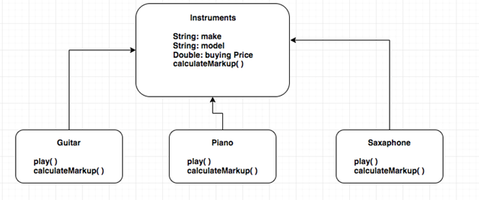

| Unit | Ref | Evidence |  |
| --- | --- | --- | --- |
| I&T | I.T.1 | The use of Encapsulation in a program and what it is doing. | |



**Here the variables used are private and can only be accessed outside the class via the methods**

| Unit | Ref | Evidence |  |
| --- | --- | --- | --- |
| I&T | I.T.2 | Take a screenshot of the use of Inheritance in a program. Take screenshots of:  *A Class  *A Class that inherits from the previous class  *An Object in the inherited class  *A Method that uses the information inherited from another class. | |

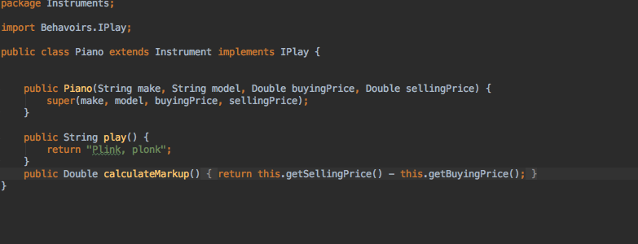

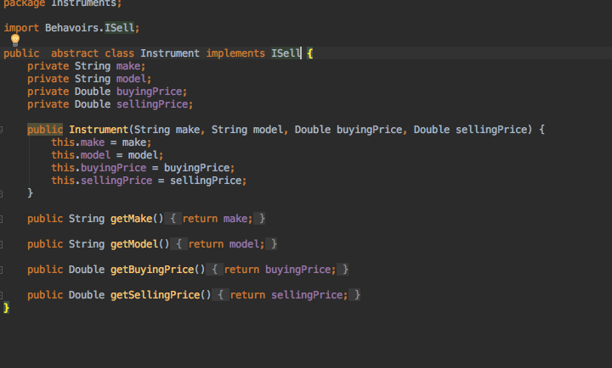

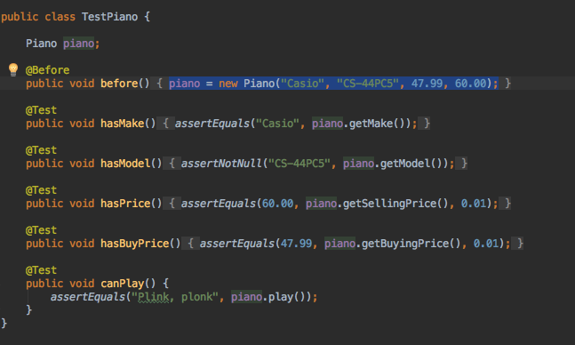

**Week 10**

| Unit | Ref | Evidence |  |
| --- | --- | --- | --- |
| P | P.11 | Take a screenshot of one of your projects where you have worked alone and attach the Github link. | |

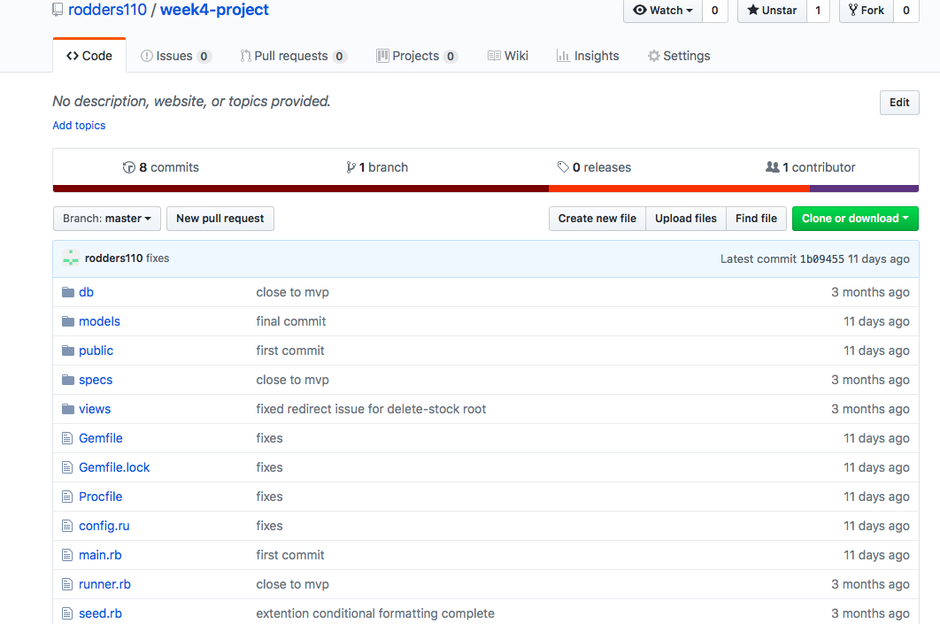

**https://github.com/rodders110/week4-project**

| Unit | Ref | Evidence |  |
| --- | --- | --- | --- |
| P | P.12 | Take screenshots or photos of your planning and the different stages of development to show changes. | |

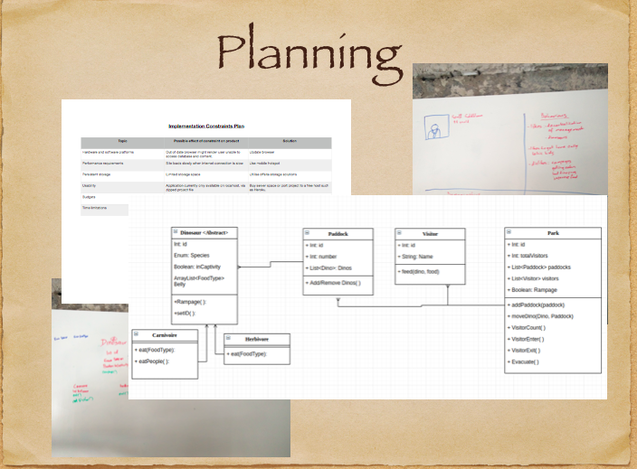

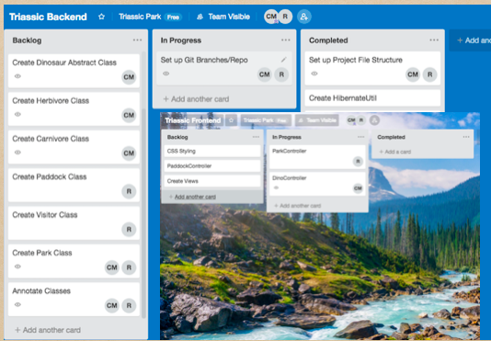

| Unit | Ref | Evidence |  |
| --- | --- | --- | --- |
| P | P.9 | Select two algorithms you have written (NOT the group project). Take a screenshot of each and write a short statement on why you have chosen to use those algorithms. | |

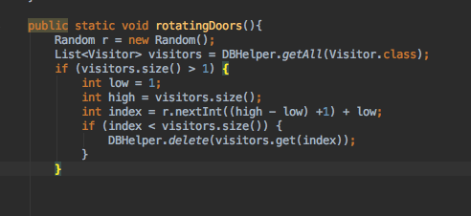

**This Algorithm selects a paddock object at Random to remove a visitor object, the create the illusion of visitors leaving the park in the project.**

**X**

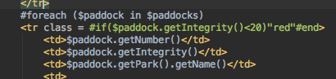

**This Algorithm generated the table information from the database and also has a conditional statement to alter the class tag of the table. Which effects the CSS.**

**Week 12**

| Unit | Ref | Evidence |  |
| --- | --- | --- | --- |
| P | P.16 | Show an API being used within your program. Take a screenshot of:  * The code that uses or implements the API  * The API being used by the program whilst running | |

From: https://github.com/rodders110/week12-WeekendHomeWork

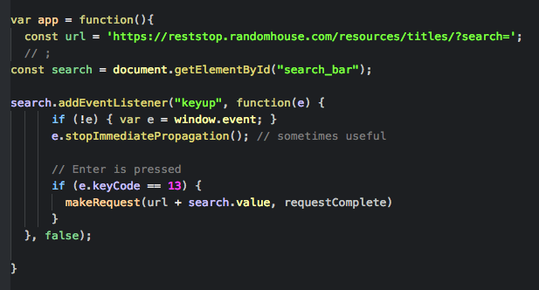

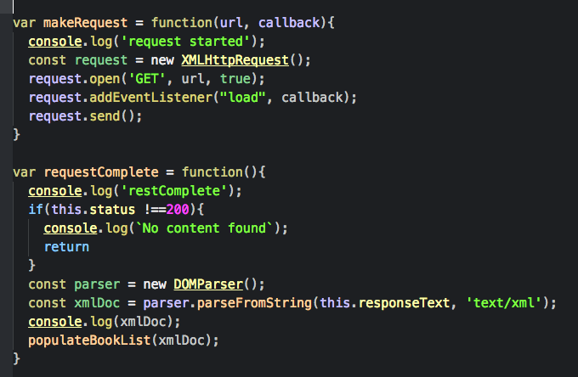

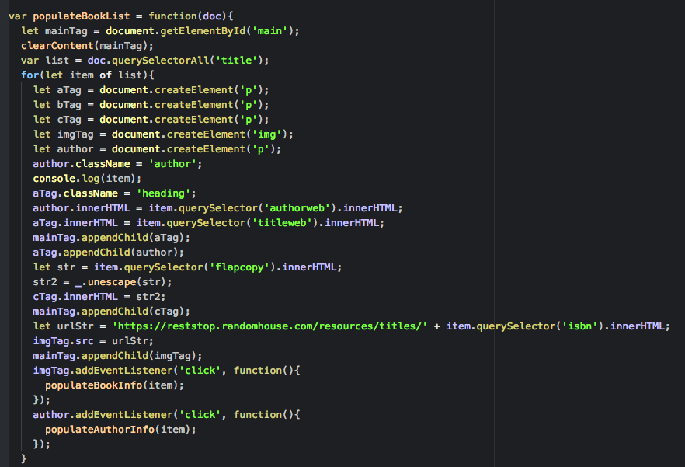

**Here the code listens out for the enter key being released in the the text box and then sends the value of this appended to the url of the randomhouse publishers API. It then generates a list of books on the index page using the response xml from the API.**

**Week 15**

| Unit | Ref | Evidence |  |
| --- | --- | --- | --- |
| P | P.1 | Take a screenshot of the contributor’s page on Github from your group project to show the team you worked with. | |



| Unit | Ref | Evidence |  |
| --- | --- | --- | --- |
| P | P.2 | Take a screenshot of the project brief from your group project. | |



| Unit | Ref | Evidence |  |
| --- | --- | --- | --- |
| P | P.3 | Provide a screenshot of the planning you completed during your group project, e.g. Trello MOSCOW board. | |



| Unit | Ref | Evidence |  |
| --- | --- | --- | --- |
| P | P.4 | Write an acceptance criteria and test plan. | |



| Unit | Ref | Evidence |  |
| --- | --- | --- | --- |
| P | P.7 | Produce two system interaction diagrams (sequence and/or collaboration diagrams). | |



*The ListItem upon click calls a function which has been passed down from main container via props. This function sets the selectedFighter state causing the main container to render. As the selectedFighter state is no longer null the hideListContainer( ) executes renders the Fighter container to show info on the selected fighter, and hide the list container.*



*When a user clicks an AddToTeam button. The function playerTeamAPICall( ) is called via a series of functions passed down as props when the AddToTeamButton is clicked.*

| Unit | Ref | Evidence |  |
| --- | --- | --- | --- |
| P | P.8 | Produce two object diagrams. | |



| Unit | Ref | Evidence |  |
| --- | --- | --- | --- |
| P | P.17 | Produce a bug tracking report | |

